RIT SIS Extension

[Thomasdemeo@gmail.com](mailto:Thomasdemeo@gmail.com) - Thomas DeMeo

[def2191@rit.edu](mailto:def2191@rit.edu) - Daniel Fenton

https://github.com/tomtuner/RIT-SIS-Extension-Mod

**Document Verbiage**

*Directory* and *Folder* are used interchangeably throughout this document.

**Mission**

This application is meant to deliver extended functionality for users, students in particular, who use the RIT SIS registration system (PeopleSoft), initially easing the transition.

**Current Features**

* Added an RIT logo and color theme to the overall system.
* Enables autocomplete functionality enabling users to search for majors in the subject line, and then the system converts it to the correct code.
* Added a GPA model on the grades page to enable projected GPA calculations based on current courses and predicted grades.
* Enhanced the overall layout of the pages (centered).
* Formatted numerical input fields to only allow for the appropriate characters and character lengths.
* Removed unnecessary verbiage.
* Added mouse over affects to describe some of the new terminology.

**Desired Future Features**

* Make the interface to create a custom banner easier and more dynamic.
* Have an API tie in to the course subjects so they do not have to be loaded in manually.
* Correct formatting of “Additional Search Criteria” link of page load.
* Integrate either RIT or Rate My Professor Scores when viewing classes/instructors.
* Matching teacher search to subject selection, and having autocomplete for teacher search.

**System Architecture**

There are two main components that go into the RIT SIS Extension system, the downloads website (http://www.sisextension.com) and the actual extension files that get loaded when using it.

The downloads website files can be located in the *Website* directory of the Git repository. This website enables users to select which browser they are using and download the appropriate extension for that browser. The Google chrome add-on can be downloaded from the Chrome Web Store, which can be found when clicking on Google Chrome through the downloads website, and the link can be found below in the repository section. The other two extensions (Firefox and Safari) are currently being distributed and delivered by the same server that the website is hosted on through Apache. The files that are being delivered can be seen in the *downloads* directory located on the server. The website also includes links to download each of the three browsers that we support.

On the home page of the website there is a picture viewer set up to view screenshots of the features we have added/changed with the SIS system through the extension. To do this we used a library called *galleria*, which can be found at <http://galleria.io/>. This is all done through JavaScript and provides an easy to use interface to load whatever images you wish using basic html tags.

This website is currently running the Apache web server version 2.2.23 and is hosted on an Amazon Web Services EC2 instance. It uses CSS, HTML, and some basic JavaScript to function. It has been configured to be able to deliver the two types of extensions required for the Firefox and Safari web browsers.

The Firefox extension is edited online through the Mozilla Add-on builder currently.

The second piece of the system is the actual extension, and the files that go along with it to get delivered when the user is on the *campus.rit.edu* portal. The image below is a rough picture describing a little bit about of the architecture of the extension works.

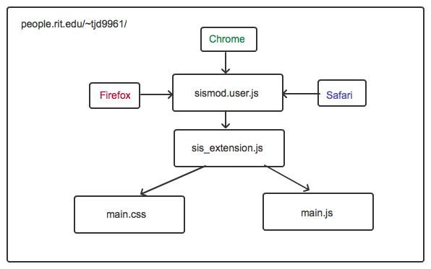

This describes the relationship that each of the browsers has their own extension that gets installed separately used the main *sismod.user.js* files in the extension, and then they load in the *sis_extension.js* file. The *sis_extension.js* file is in charge of loading the files used as the core of the application. Currently this files loads the *main.css* and the *main.js* files into the browser. *Main.css* is in charge of modifying the layout and visuals of the application and *main.js* handles adding functionality, modifying tags, keeping track of colors and url/uri’s needed to load specific aspects of the page. It also handles loading specific features only on certain pages of the extension, as well as handling the problem of the page reloading itself even when it should not.

**Repository Breakdown**

*Browser Addons*

This folder contains the files for the specific add-ons created for the individual browsers.

*Safari*

The main files for the Safari extension. The actual extension file delivered is “RIT SIS Extension.safariextz”.

*Chrome*

The main files for the Chrome extension. This is currently published on the Chrome Web Store at <https://chrome.google.com/webstore/detail/rit-sis-extension/eoffkcomahdnenajelomgfdlcganfifg>.

*Opera*

The Opera extension currently was never completed or got fully functional. Since Opera is moving to WebKit in the future this may open up an easier path to develop an Opera Extension.

*Documentation*

Contains this document and any other documents we have created associated with the extension.

*Images*

Any images we have created for either the downloads website, the extension itself, or the Facebook page are located here. Some of the screenshots used on the downloads website are also located here.

*Screenshots*

Originally meant for all of the screenshots associated with the extension but now only contains a few .png’s that were previously used when downloading one of the browser extensions.

*sismod.user.js*

The original GreaseMonkey script used for the extension, this is still used as the initial loading for some of the Browser add-ons. This file loads a separate JS file to futher grab the rest of the necessary files for the extension.

*src*

The main source directory used for the source files of the extension. This includes the main *sis_extension.js* file that loads the rest of the necessary files to the browser. It also includes the core directories of the extension in the js and css directories.

*test*

The test directory used for testing purposes of new features or bug fixes. This includes the test GreaseMonkey script *sismod_test.user.js* that is used with the Chrome browser. This points to the test location to load a different set of scripts for testing purposes.

*Website*

This directory holds the core of the downloads website, located at sisextension.com. This includes the three separate pages for downloading the browser add-ons, the galleria files for the picture viewer on the site, the css and js files used, as well as the images used for the site.

**Feedback Mechanisms**

*Facebook*

Currently the main form of feedback comes from our Facebook Page. We promote updates through this, collect issues or bugs people find and take recommendations for future features. This page can be found at <https://www.facebook.com/sisextension>.

*Google Analytics*

Google analytics is currently integrated into both parts of the system architecture, the downloads website as well as the actual extension. This gives us information as to who is downloading the extension as well as who is using it at any given time. Data such as how many pages we are improving, how many active users we have, and how many GPA’s we have predicted are just some of the useful statistics we have to analyze.

This gives us more feedback about which browsers are being used the most, the locations where people are using the extension, and if people are interacting with the features we have added.